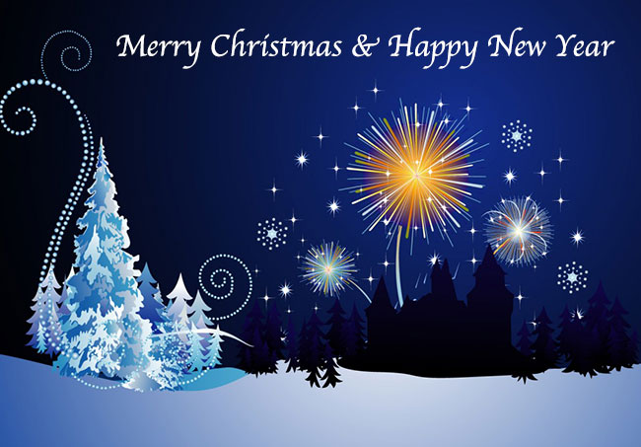

A Happy and Peaceful Christmas to all readers of Lorrhadorrha.ie and a very happy New Year.

Thank you for your kind comments, contributions and help during 2014 and we look forward to hearing from you all again in 2015 wherever you are in the world.

